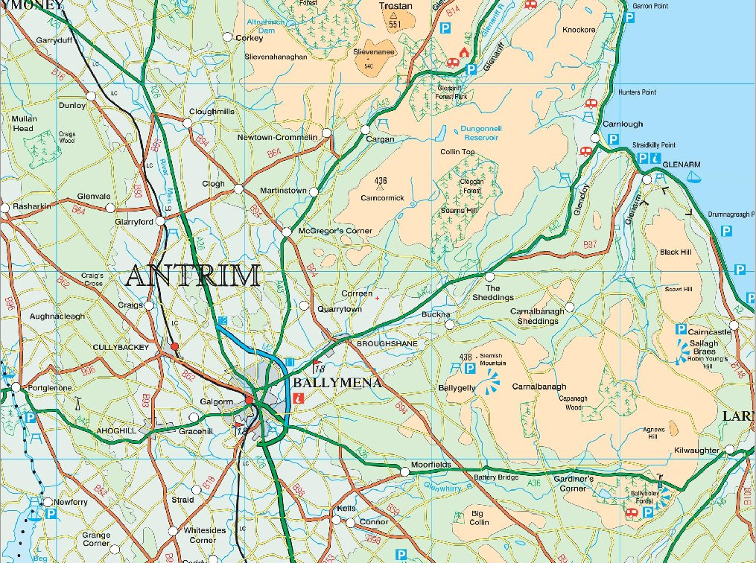
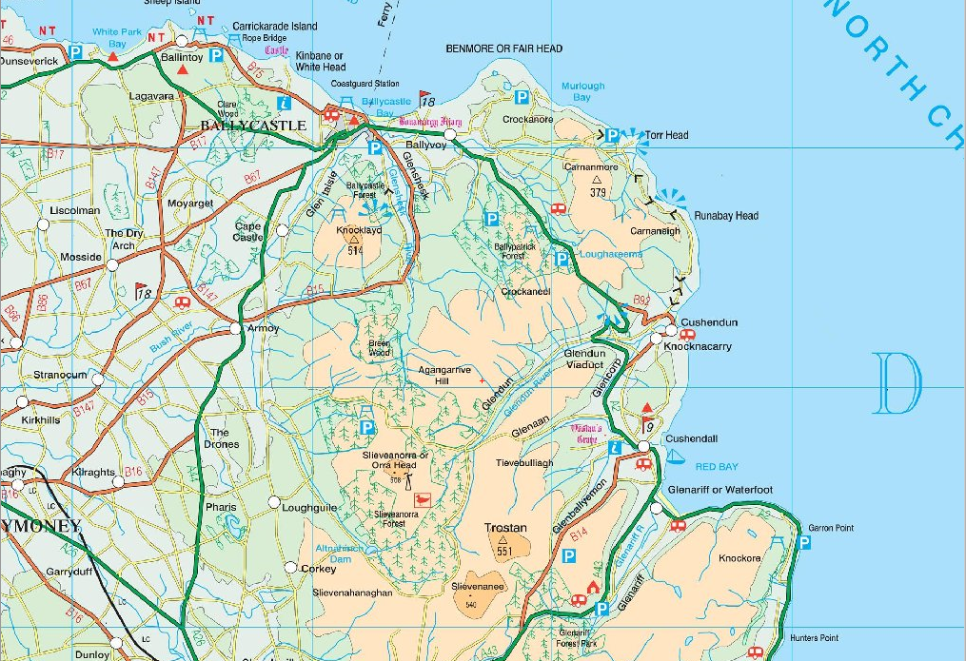
1
3
2
1 – Ballycastle Seafront (Break 10mins)
2 – Cushendall Lifeboat Station (Lunch)
3 – Carnlough Harbour (Break 10mins)

Outward Route:

- Starting in Ahoghill at Cullybackey Road car park
- Ride into Cullybackey along the Cardonaghy Road
- Turn left onto Kilrea Road (opposite Maxol filling station) and continue for 0.4 miles
- Turn right onto Hillmount Road and continue to end
- Turn right onto Dunminning Road and continue for 6 miles
- Turn right onto Anticur Road and continue for 1 mile
- Turn right on Boyds Road and continue to end
- Turn left onto Killagan Road and continue to end
- Across staggered junction onto Drumadoon Road and continue to end
- Turn left onto Culcrum Road and continue for 250 metres
- Turn right onto Ballyveely Road and continue for 3.9 miles
- Turn right onto Lough Road and continue to end
- Turn left onto Coolkeeran Road and continue to end
- Turn right onto Glenshesk Road and continue to end
Break at Ballycastle seafront (32 miles)
- Turn left onto Mary Street and continue for 0.2 miles
- Turn left onto Cushendall Road/Loughareema Road/Tromra Road and continue to end (Cushendall)
- Turn right onto Coast Road and continue for 0.6 miles
- Turn left into carpark at Cushendall Lifeboat Station (48 miles)

Return Route:

- Starting at carpark at Cushendall Lifeboat Station
- Turn right onto Coast Road and continue for 9 miles (Carnlough)
Break at Carnlough Harbour (57 miles)
- Continue along Coast Road for 0.7 miles
- Turn right onto Ballymena Road and continue for 12 miles into Broughshane
- Turn right at mini roundabout onto Knockan Road and continue for 0.3 miles
- Turn left onto Ballygarvey Road and continue to end
- Turn left onto Cushendall Road and continue for 250 metres to Cushendall Road Roundabout
- Take third exit onto Grove Road and continue to end to Grove Roundabout
- Take second exit onto Carnburn Road and continue to end
- Turn right onto Carniny Road and continue to end
- Turn left onto Woodtown Road and continue to end
- Turn right onto Cullybackey Road and continue for 2 miles onto Dreen Road
- Turn left onto Cardonaghy Road and continue along into Ahoghill
- Finish at Cullybackey Road car park (80 miles)

